Bundle 2: The Culture of Consumption

Tess Atkins

WRT 302

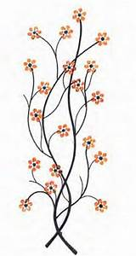
D.I.Y. with Whiskey and Rye

Table of Contents

Title of the Product/Service:

D.I.Y with Whiskey and Rye

Description:

D.I.Y. with Whiskey and Rye is a company that hosts events in pop-up locations from 5-7 p.m. for happy hour every Friday night. This event is an opportunity for young adults to create “do it yourself” home decorations while sipping on whiskey and rye drinks. The event will cost $30 a person which will include an open bar and all the materials they will need for creating their home decoration. People attending the event can choose from three different home decorations to make and will be taught how to make them from high qualified local art teachers from schools and universities in the area.

Bundle Documents:

Menu
Billboard
Two Letters (complaint and response to customer’s complaint)
Brochure
Blog Review

Intended Audiences and Distribution
- Menu (188 words)
  - People who attend D.I.Y. with Whiskey and Rye will be selecting what they will be ordering for a drink as well as selecting which D.I.Y. home decoration they will be making. These customers will be ages 21-35 who are interested in a fun girls’ night out, looking to have a fun, different experience with a significant other or any friends or family who love to doing D.I.Y. projects together.
  - Available on the D.I.Y. with Whiskey and Rye website as well as the event itself. When customers arrive, they will be greeted and handed a menu.

- Billboard (18 words)
  - Anyone from the age 21-35 who are driving on the highway through populated towns such as Fairfield and Westport, CT or Burlington and Woodstock, VT. These people are particularly interested in what goes on in the town they drive through, or surrounding towns where they live.
  - The billboard will be on main highways such as I-95 or I-91 and will provide a phone number and the company’s website so people can call or look on their website where the next D.I.Y. with Whiskey and Rye event is near them.

- Two Letters (634 words)
  - Received by the main office of D.I.Y. with Whiskey and Rye, addressed to the CEO, and received by the concerned/unhappy customer.
  - The concerned/unhappy customer sent a letter to D.I.Y. with Whiskey and Rye’s main office addressing her complaints and bad experience that she had at the event she attended. The CEO of D.I.Y. with Whiskey and Rye responded to the customer’s letter addressing the complaints and mailed the letter back to the unhappy customer.

- Brochure (237 words)
  - The audience for this brochure will be anyone from the ages of 21-35 (mostly women) who shop at retail stores such as Free People, Urban Outfitters and Anthropology. For people who shop at hardware and home stores ages 21-35 such as Home Depot, A.C. Moore, Michaels Arts & Crafts, and so on. This brochure is also targeted towards young adults ages 21-35 who enjoy going to local coffee shops or cafés.
  - Available in all stores and retail stores listed above as well as local coffee shops and cafés.

- Blog Review (697 words)
  - Readers of the Tess did what?! Blog that are interested in food, lifestyle, and travel. This blog targets a broader audience, ages 18-35. People who read this blog have followed the blogger for a while and is interested in what the blogger is up to each week. People who love to travel, try new foods, or try out new local events would be particularly interested in this blog post.
  - Available online at www.tessdidwhat.com, which can be accessed through a simple Google search or typed into the URL.

Postwrite (separate document): 882 words
Table of Contents: 598 words

Total Bundle Word Count: 3,070 words

Menu

D.I.Y. with Whiskey and Rye

MENU:

STEP 1: Pick your drink!

DRINKS:

Classic Whiskey Sour
- Pink lemonade, ginger ale, Stella Artois beer, and Jim Beam Whiskey, garnished with lemon and ginger

Rye Manhattan
- Sweet vermouth, Angostura Bitters, George Dickel Rye Whiskey, garnished with a cherry

Rye and Pomegranate Punch
- Fresh lemon juice, pomegranate juice, simple syrup, Luxardo Maraschino liqueur, Peychaud’s bitters, club soda, George Dickel Rye Whiskey, garnished with pomegranate seeds and a lemon
- Ask for a virgin version as well if it suits you better!

Espresso Old Fashioned
- Double shot espresso, bourbon whiskey, simple syrup, Pechaud’s bitters, garnished with a lemon peel

Drink of the Week
- Ask your bartender what the DRINK OF THE WEEK is!
- You can also ask for a “drink of the week” that you have had at one of our past events!
- Ask for a virgin version as well if that suits you better!

STEP 2: Pick your D.I.Y. decoration!

DECORATIONS:

Wall Hangings
- Choose from macramé or plants

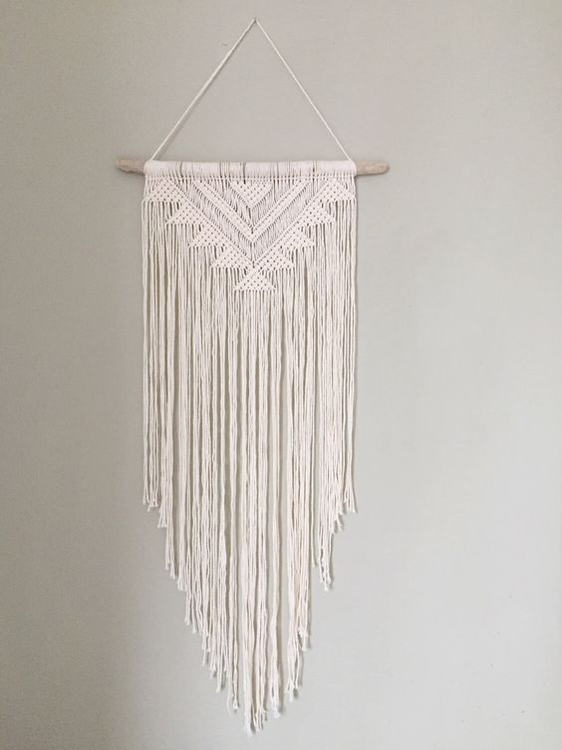
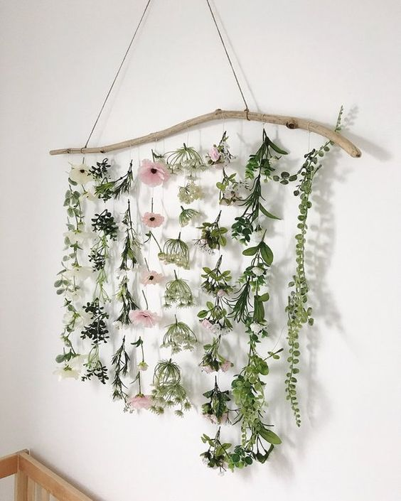

Faux Succulent Garden
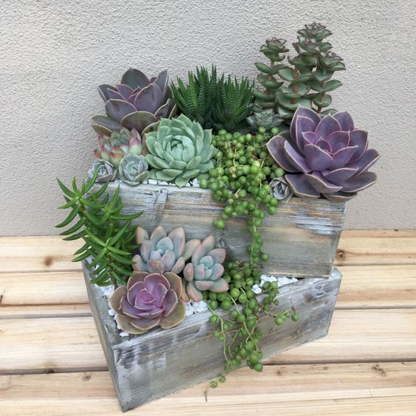

Paint Your Own Wooden Storage Bins
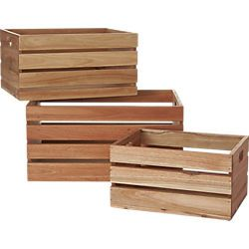

STEP 3: D.I.Y with Whiskey and Rye!

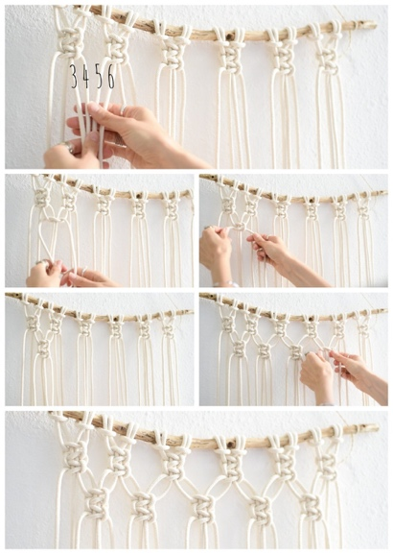
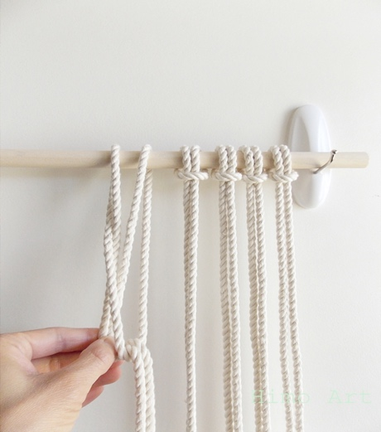

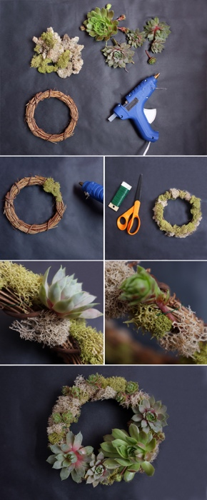

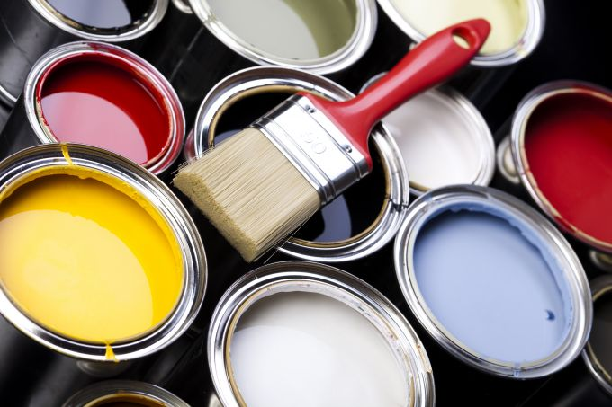
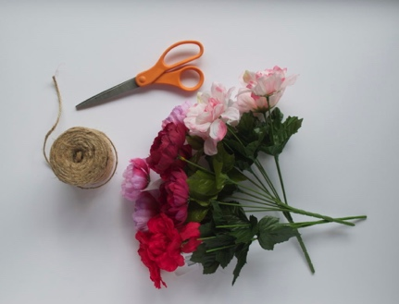

Billboard

Create and Clink!

D.I.Y. Home Décor with Whiskey and Rye
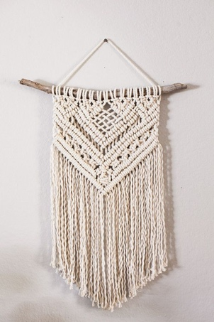

FOR DETAILS:

Call 555-2345

Or go to

www.diywhiskeyandrye.com

Two Letters:

To:
D.I.Y. with Whiskey and Rye
123 Main Street
Fairfield, CT 06640

To whom this may concern,

I would like to voice my complaints about your recent event that I attended. I went to the D.I.Y. with Whiskey and Rye event on March 25, 2019 at the pop up warehouse in Westport, CT and was so disappointed from the moment I arrived, to the moment I left.

I went to your event with three of my girlfriends from college. As soon as we walked into the event, we were overwhelmed. With arts and crafts spread out everywhere, no organization and not to mention that no one even greeted us when we walked in. I personally felt very unwelcomed and I’m very upset about my arrival experience.

Thinking it was going to be a fun event to go to with the girls, after choosing from the menu which decoration we were each going to make, we were separated and unable to sit together. This defeated the entire purpose of going to do something fun with your friends, since we were unable to sit together. Not to mention that making these home decorations was incredibly stressful and not at all fun in any way. Although the teachers tried their best, I gave up making my macramé wall hanging only thirty minutes in to the event.

The drinks were not good at all. The whiskey sour was way to overpowered with lemonade and the rye and pomegranate punch tasted like straight rye. I couldn’t finish either drink.

I truly feel as if my $30 was completely wasted. We could have gone out to dinner with that money and had a much better time. I would like to be refunded my money, and I would also like for you to make changes to your event so other people do not have the same experiences that I did.

Thank you,

Alaina Cascarina

D.I.Y. with Whiskey and Rye
123 Main Street
Fairfield, CT 06640
203-555-2345
April 3, 2019

Mrs. Alaina Cascarina
Interior Designer
IntoDesign
321 Boulevard Lane
Manasquan, NJ 09854

Dear Mrs. Cascarina,

Thank you very much for reaching out and discussing your recent experiences at one of our events. I am sorry to hear that your time at D.I.Y. with Whiskey and Rye was not what you expected.

All of our staff work very hard to ensure that every guest at the event has a pleasant time, and makes sure everyone is having fun while making their own, unique home decoration!

Each home decoration is separated into groups so that our teachers can give their full attention to the people in their groups. This way, everything stays organized and all of our teachers are able to assist anyone who needs help or has questions.

Unfortunately, I am unable to give you a full refund. All of the proceeds go to our companies who donate supplies and materials as well as pay our teachers and pay for ingredients to make the drinks.

I can however, offer you and your friends to come to another event for a discounted price of $15. The next event will be held on April 10, 2019 at the same location as the last event you attended.

My team and I hope you can make this event and we hope that you have a better experience. If you have anymore questions or concerns, please don’t hesitate to reach out. We appreciate hearing your feedback and hope to see you at another one of our events soon!

123 Main Street
Fairfield, CT 06640
April 3, 2019

….

Again, thank you very much for sharing your experience and reaching out to us. We hope that you come to another one of our events in your area!

Sincerely,

Tess Atkins

Tess Atkins
CEO of D.I.Y with Whiskey and Rye

Brochure – ON SEPARATE ATTACHMENT

Blog

Tess did what?!
_____________________________________________________________________________
About Me Travel Lifestyle Food Contact Me
______________________________________________________________________________

D.I.Y. With Whiskey and Rye for the perfect Girls Night Out!
April 13, 2019, 12:00 p.m.

Hello again everyone! As always, thanks for coming back to my blog to see what I did this week!

This week I visited my hometown of Fairfield, CT to see all my friends from high school and to visit family that I haven’t seen in a while. If you’ve never been to Fairfield, it is a beautiful town with a wonderful downtown area and the best part? It is right on the water! Every time I go back home, it seems to get more and more beautiful.

But I am writing today about the best Friday night happy hour I have had in a long time. My friends and I kept hearing about this event where you go and make your own home decorations while drinking fun whiskey and rye drinks. So OF COURSE we had to check it out! We drove twenty minutes to Westport, CT to their location on the main strip of the downtown.
The space that they had was situated right in-between LuLu Lemon and The Loft, with a sign that read, “D.I.Y. with Whiskey and Rye” right above the entrance door! At first glance, we were all so excited to see what was to come next!

As soon as you walk in, the whole vibe of the huge open room just radiates. Huge beautiful clay planters hanging from the ceiling with long ivy leaves draping out, macramé wall hangings scattered everywhere across the walls, beautiful wooden working stations with beaded chairs for people to sit, the rugs looked they were from a Pintrest post (very Moroccan style), big industrial stringed lights draped down from the entire ceiling, and a bartender towards the back of the room mixing up some delicious looking drinks. All I can say is, when we first walked in, we were in awe at the bohemian beauty of the pop-up location!

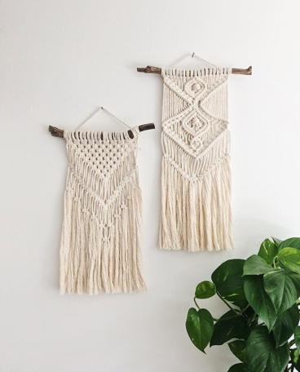
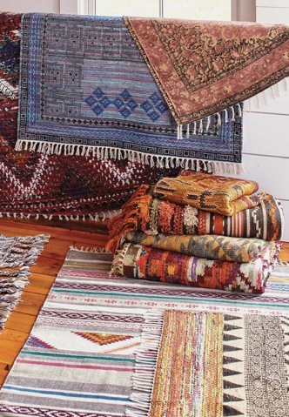
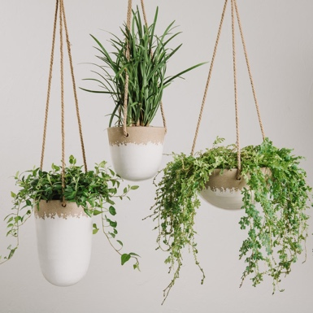

So after our arrival, we each paid $30, they take both cash and credit/debit cards and we are then handed a menu by the lovely workers. The menu is so simple to read and easy to follow! First, you pick out which drink you would like to get and your options include a classic whiskey sour, rye Manhattan, rye and pomegranate punch, an espresso old fashioned or the drink of the week! The drink of the week for our event was a whiskey and citrus drink, which let me be the first to tell you, was DELICIOUS! Second, you pick out which decoration you want to make and your choices include wall hangings, a faux succulent garden or you can decorate your own storage bins. We all decided to make our own macramé wall hangings so we would all be together!

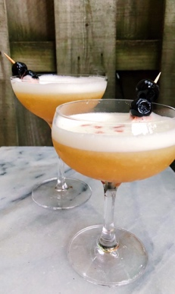
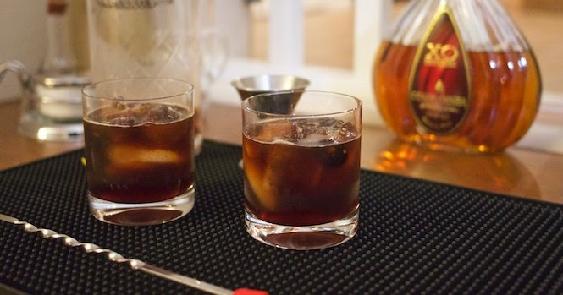
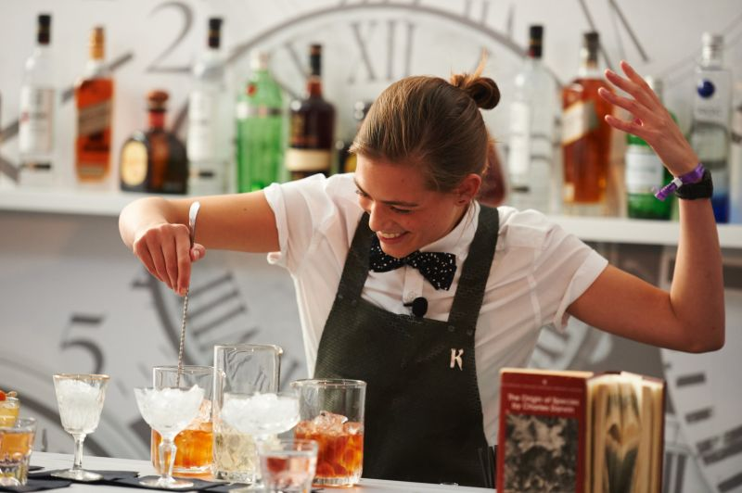

After getting our drinks and deciding which decoration we were going to make, we were guided to a working table where they had all of the materials laid out; fake flowers for a flower wall hanging, string for macramé, wooden sticks to hole your hanging and string to attach to the wooden sticks so you can hang it when you get home!

Then we began DIYing and sipping! We all had so much fun, and all of the teaches were so helpful, patient and so good to work with. We all were able to work at our own pace which was great!

This is a company that hosts their events in pop-up open building locations! If you are interested in finding on of there events near you, head to their website or give their headquarters a call! Both are listed below!

Website: www.diywhiskeyandrye.com
Phone Number: (203)-555-2345

The overall environment was amazing and I couldn’t have asked for a better girl’s night out for happy hour! I would highly recommend going to one of D.I.Y with Whiskey and Rye’s events, they are so fun! Below I will post a link to their website and don’t forget to checkout my Youtube channel for the vlog of my visit with my friends (I will also post that link)!

Hope you come back next week to read about what I do!

Attachment: www.diywhiskeyandrye.com
Attachment: www.youtube/tessdidwhat/vlog.com

