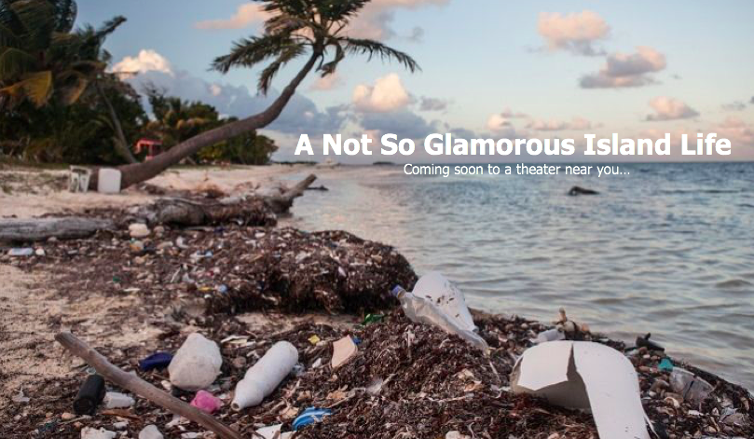

Bundle One: The Culture of Performance
Tess Atkins
The University of Rhode Island
Professor Genoa Shepley
WRT 302

Table of Contents

- Performance Title:
A Not So Glamorous Island Life

- Venue:
The movie will be shown in movie theaters all over the country. The movie will also be shown at the Environmental Film Festival in the Nation’s Capital as well as the Culture and Diversity Film Festival. The movie will also be shown at universities for students to attend and learn from the film.

- Description of Performance:
“A Not So Glamorous Island Life” is a movie about a 17-year-old girl who is sent to The Island School in Eleuthera, Bahamas for one month over her summer vacation. Throughout the month at the school, Dylan the main character, learns all about climate change and how it affects the biodiversity and human life of the Bahamas, the traditional Bahamian culture through a native family of the island and develops a love story with the family’s son. The month away from home teaches Dylan that there is more to life that matters rather than her materialistic lifestyle that she is used to. This movie is a story about how culture can bring people together.

- Bundle Documents:
- Flyer
- Radio Spot Advertising
- E-Blast
- Feature Article
- Facebook Post

- Intended Audience:
  - Flyer:
The audience intended for the flyer are males and females ages 18-30. Students studying environmentalism or culture are specifically intended to be the main audience for this flyer. The flyer would be posted in coffee shops, university buildings on bulletin boards and posted as ads on websites like National Geographic and Facebook.
  - Radio Spot Advertising
The radio spot advertisement will target males and females ages 18-30 who listen to popular music stations. For example, 92.3 which plays “today’s top hits.” The advertisement is light hearted and only a few seconds so this targeted audience won’t skip the channel before the advertisement is over.
  - E-Blast
This e-blast in particular focuses on one person. This person is anywhere from 18-21 years old and attends a university or college. This person is a part of the environmental or anthropology school within the university and is interested in learning more about these subjects.
  - Feature Article
The feature article’s intended audience is anyone 18 years of age or older who regularly reads National Geographic. The feature article will be in their publication as well as their website so that audiences who like online reading and non-online reading will have access to the article.
  - Facebook Page
The Facebook page attracts a broader audience. Families of all ages, college students, adults and teenagers who have a Facebook have access to the Facebook page. Anyone who likes to be a part of pages or groups on Facebook will benefit from this page because it will give readers information about the movie, the actors and interactive polls for people to partake in.

- Distribution:
Flyer: The movie flyer will be distributed in cafes around towns and cities, in universities, high schools on bulletin boards and posted as ads on websites like National Geographic and Facebook.
Radio Spot Advertising: The radio spot advertisement will be on popular radio stations in every major city. Radio stations that play top hits of every genre on FM stations, as well as Serius XM, will advertise the movie with the script.
E-Blast: The e-blast will be sent to specific people at universities or publications that focus on environmentalism and/or anthropology. The e-blast will be sent by universities and by National Geographic to people on their subscription list.
Feature Article: The feature article will be published in National Geographic because it is an article about a movie that showcases the importance of learning about different cultures around the world as well as raising awareness to climate change and its affects on our earth.
Facebook Post: The Facebook page will be distributed on Facebook but people will have the option to share the page on other social media platforms such as Twitter and Instagram.

WORD COUNT: 4,097

Movie Flyer

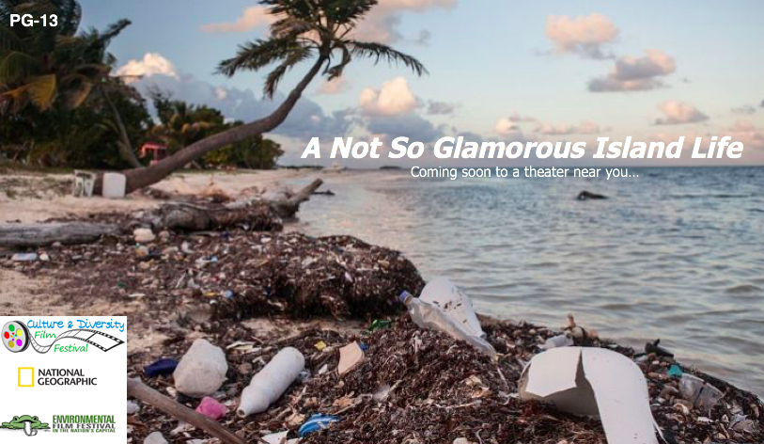

Radio Advertisement

Event: Premier of “A Not So Glamourous Island Life”

Gender: Male or Female; Length: 30 seconds; Target Demographic: Working people or students who are studying conservation and different cultures around the world, ages 18-30; Vocal Direction: Upbeat, simply language, typical announcer voice with enthusiasm; Suggested Music: cultural Bahamian music (drums, shakers, etc.); Suggested Sound Effects: ocean waves, money noise (cha-ching)

“Go on a journey to the Bahamas with a girl who is on a journey to find herself. Join Dylan as she attends The Island School in Eleuthera and learns about climate change and the environment. Along the way, watch as a love story develops between Dylan and a local boy teaching her all about his Bahamian culture. Join in on the fun adventure of being in the Bahamas for the summer in “A Not So Glamourous Island Life!” Purchase your tickets are on the Facebook page, A Not So Glamorous Island Life! First 100 people to arrive on opening day at a theatre near you will receive one large popcorn and soda! “A Not So Glamorous Island Life” coming April 2nd to a theater near you!

E-Blast – Letter Style

February 20, 2019

Dear Mr. Guilmette,

Do you ever think about the island culture? Do you ever wonder what climate change is doing to islands? Do you ever wonder who lives on these islands? Do you dream of meeting your one true love? Luckily for you, I have all the answers that you’re looking for!

A Not So Glamorous Island Life is a new movie that will satisfy your expectations of the culture, the Bahamas, climate change and more! This movie takes you through the journey of a girl named Dylan who is sent to The Island School for a month during her summer vacation. Dive into the culture of the Bahamas by engaging yourself in the native Bahamian characters, enjoy the scenery of the Bahamas and the wildlife as Dylan learns about the environment through scuba diving and snorkeling and most importantly, immerse yourself in a brand new world with amazing people and scenery of the beautiful Eleuthera, Bahamas. Directed by Tess Atkins who has won several Oscars, expect to see a life-changing performance by Tess as she stars in the movie as well.

Mr. Guilmette, we want you to be one of the first students to receive an exclusive ticket to the movie showing at your school next weekend for environmental and culture awareness week. At only $10 a ticket for you, you would be helping raise money and awareness to the Bahamian culture and climate change. This is half the price of a ticket at a movie theater! You will also receive free popcorn and a beverage of your choice. All we ask is that you post a review of the movie on our Facebook page, “A Not So Glamorous Island Life,” so people all over can get an idea of what to expect from a trusted student! We accept online payments through our Facebook page or, if you agree to come to the viewing, you can pay cash at the door. All proceeds will go to culture research in the Bahamas and climate change research at your school.

Spend your Sunday afternoon in your dorm room, or come to the viewing of A Not So Glamorous Island Life for only $10 and free snacks and drinks! I look forward to hearing from you soon about this opportunity.

Sincerely,

Theresa Atkins
Theresa Atkins
Marketing Director

Feature Article

The Inspiring Story of a Girl and the Bahamian Culture
By: Theresa Atkins Feb. 25, 2019

Narragansett, R.I. – As she walked into the interview, she was dressed in green linen pants, platform sneakers, an over sized black sweater, an orange fuzzy coat and a big round straw beach hat. The outfit seemed to be a bit weather confused but it was obvious that she had just gotten off her flight from filming “A Not So Glamorous Island Life” in the Bahamas to come and have a chat with me here at the National Geographic office.

Tess Atkins, the actress who plays the main character Dylan in the movie, was casted because of her zest for life, her attitude towards hard work, her perfectionism and her ability to immerse herself into a new world and become the character that the script portrayed. “I was so excited when I got the phone call,” Atkins said, “I felt honored to be a part of what this movie stands for and the story that it tells to the audience.”

This exciting, adventurous and self-journey movie takes a 17-year-old to a brand new world. The main character, Dylan, raised in America is obsessed with the materialistic things in her life including clothes, electronics and social media. Her parents decide to trick her into spending a month of her summer at The Island School in Eleuthera, Bahamas to learn about the things in life that are worth more than an Instagram account or the coolest handbag.
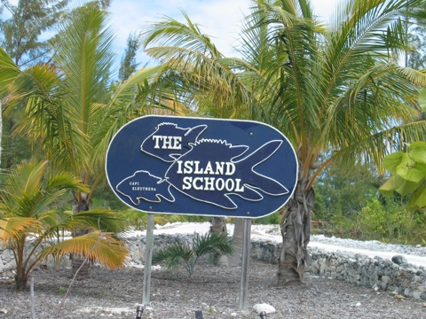
At The Island School, Dylan learns all about climate change and how it affects the biodiversity of the island and the ocean as well as how it affects the people who live on the island as well. “Working in such a beautiful destination for three months while filming, I got to experience the island first hand,” Atkins said. Atkins went on to explain how she got to experience the true culture of the Bahamas like the food, the music, how to Bahamians live their everyday life and she also got to experience what means most to these islanders.

In a world like today, climate change has become a huge topic of conversation amongst everyone. Most importantly, everyone is affected. Indigenous people on islands all over the world are severely impacted. Because of rising sea levels, ocean acidification and higher risks of more detrimental storms, just to name a few, islanders are in more danger than mainlanders when it comes to climate change.

The movie really does a great job in showing how the dangers of climate change and culture can bring people together to live a better life.

“I was able to take the experiences that I had off set on the island and incorporate them into Dylan’s character,” Atkins said. Working with actor, Philip Adrian, and Atkins, the love story that develops between him and Atkins is, “Such a beautiful representation of how culture can bring two people together,” Sean McNamara, the movie’s producer, said.
Adrian plays a teenager names Cyril in the movie. In the movie, his family is a native family from Eleuthera who takes Dylan under their wing to teach her all about the Bahamian culture and their particular way of life. As Dylan spends more and more time with Cyril’s family they slowly start to fall in love. “The decision that Dylan has to make at the end of the movie either makes or breaks their love story,” Atkins said but she did not give away what the ending entails.

“This movie really captures the importance of culture and the importance of people coming together through culture,” Atkins said. She is honored to be a part of something so huge and so impactful to young adults in our world today.

The journey that Dylan took to find herself, learn about the environment and the impacts humans have on biodiversity as well as the ability to learn about a completely foreign culture in order to bring people together was a, “truly beautiful experience,” Atkins said with a huge smile and a few happy tears in her eyes.
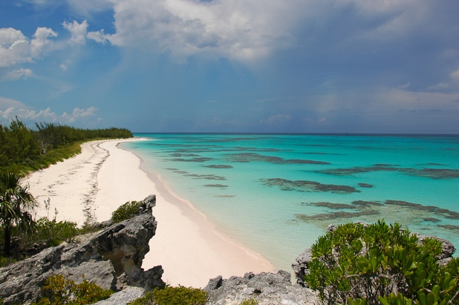

“A Not So Glamorous Island Life” will be in theaters everywhere on April 2, 2019. You can purchase tickets on the movie’s Facebook page in advance or, you can purchase tickets at your movie theater.

Take a seat, grab a popcorn and join Dylan in her adventure of new cultural experiences and love in “A Not So Glamorous Island Life” this April.

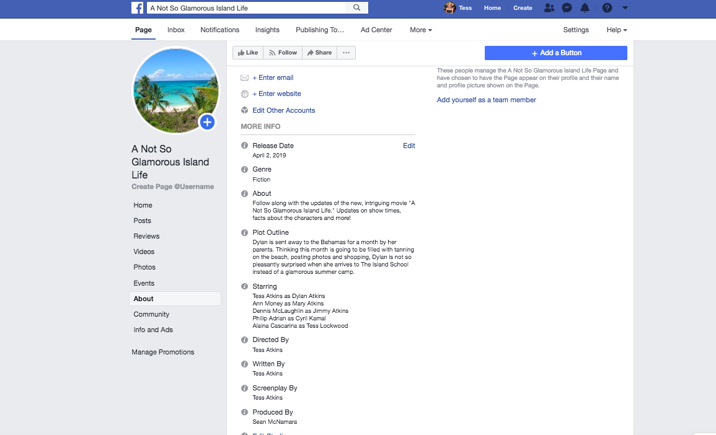
Facebook Page

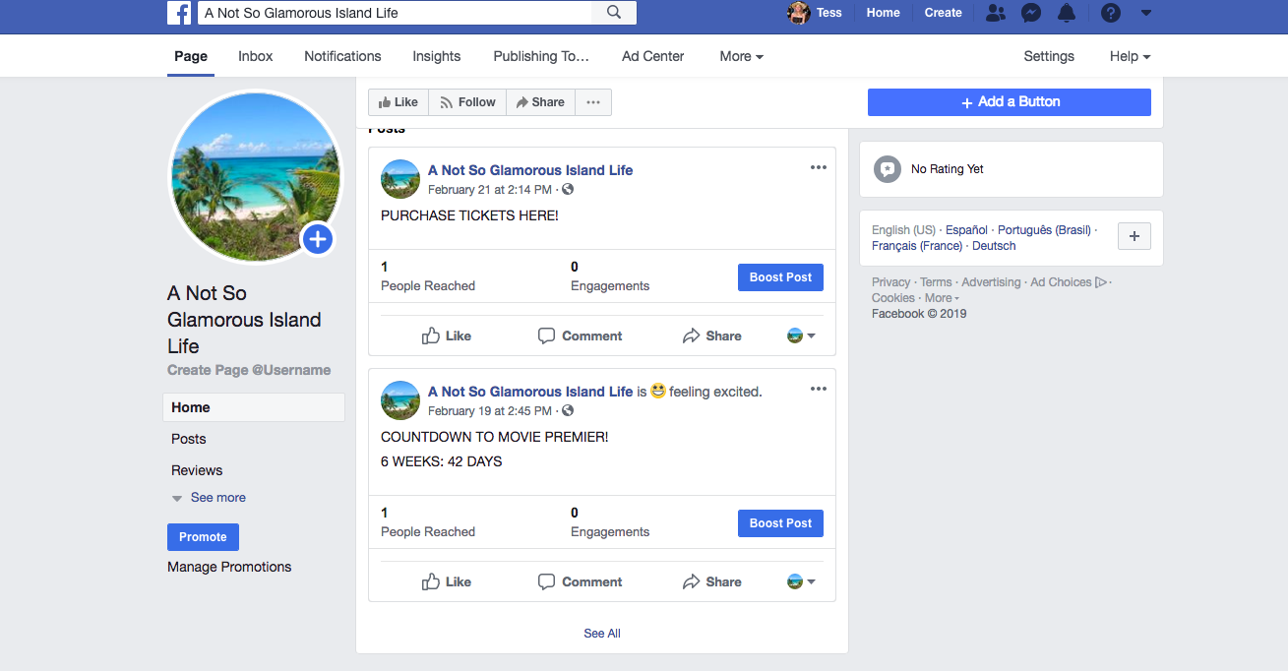
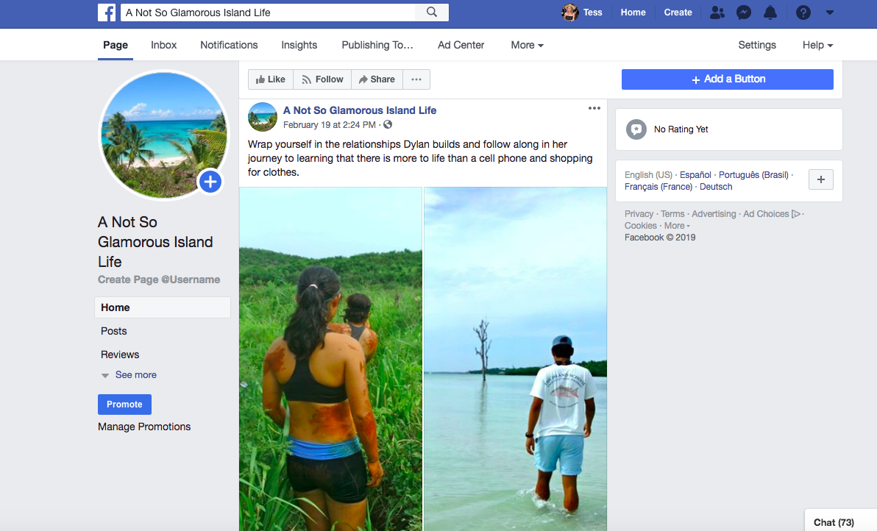
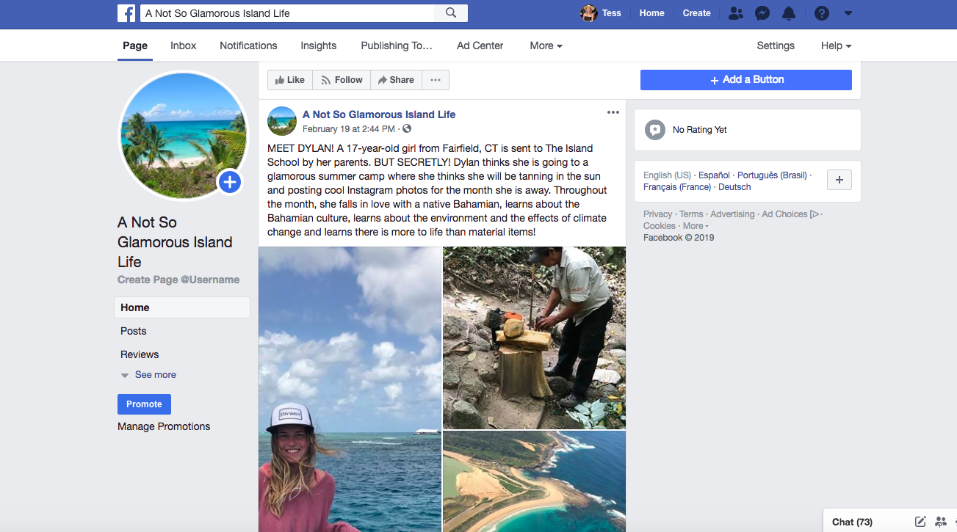
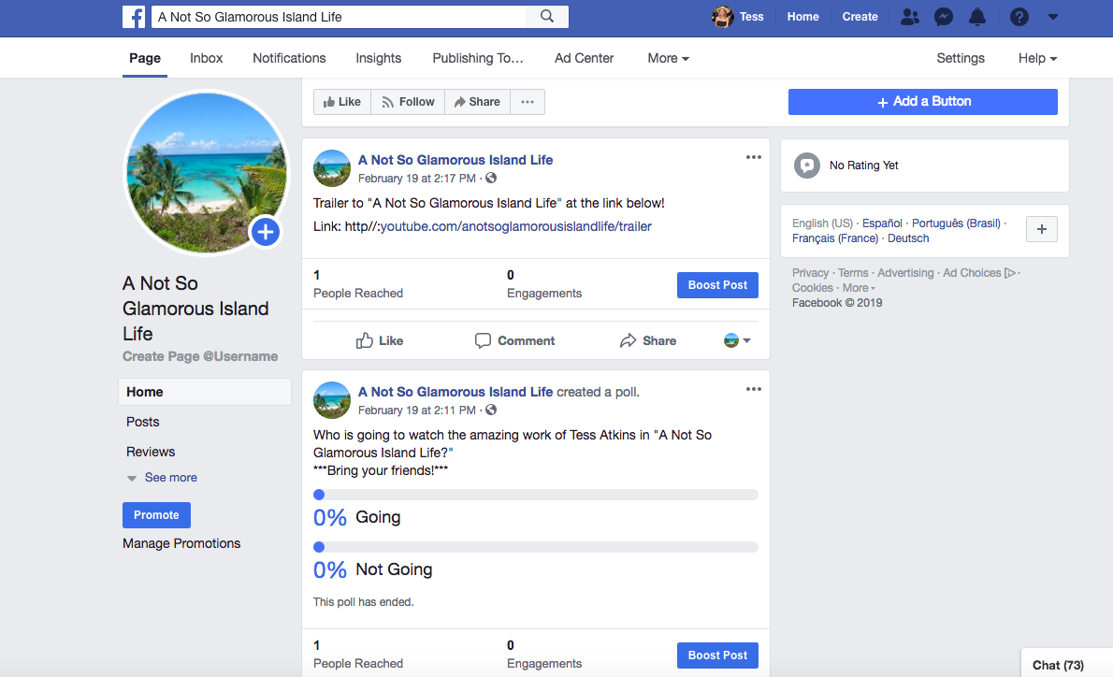
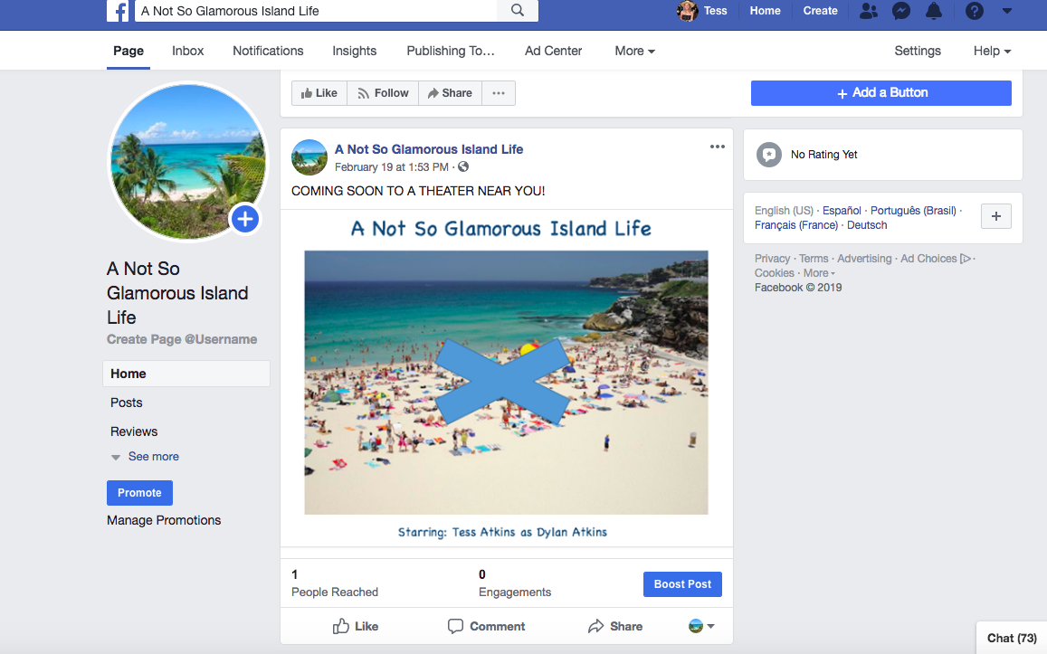
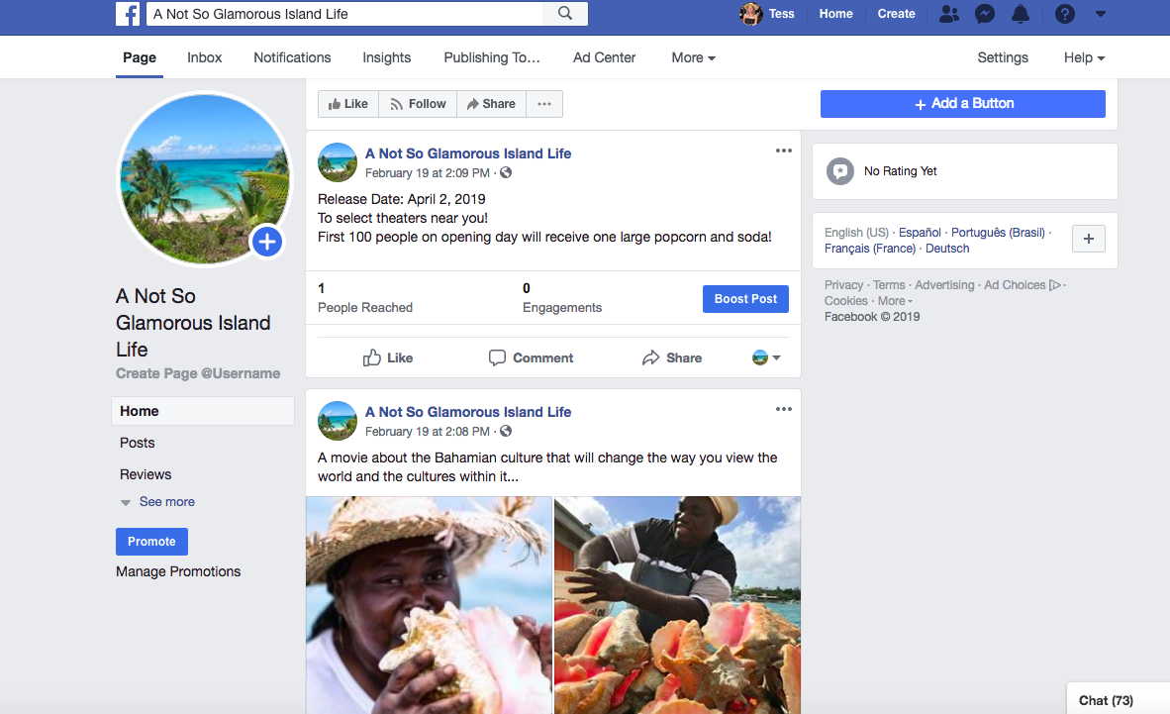

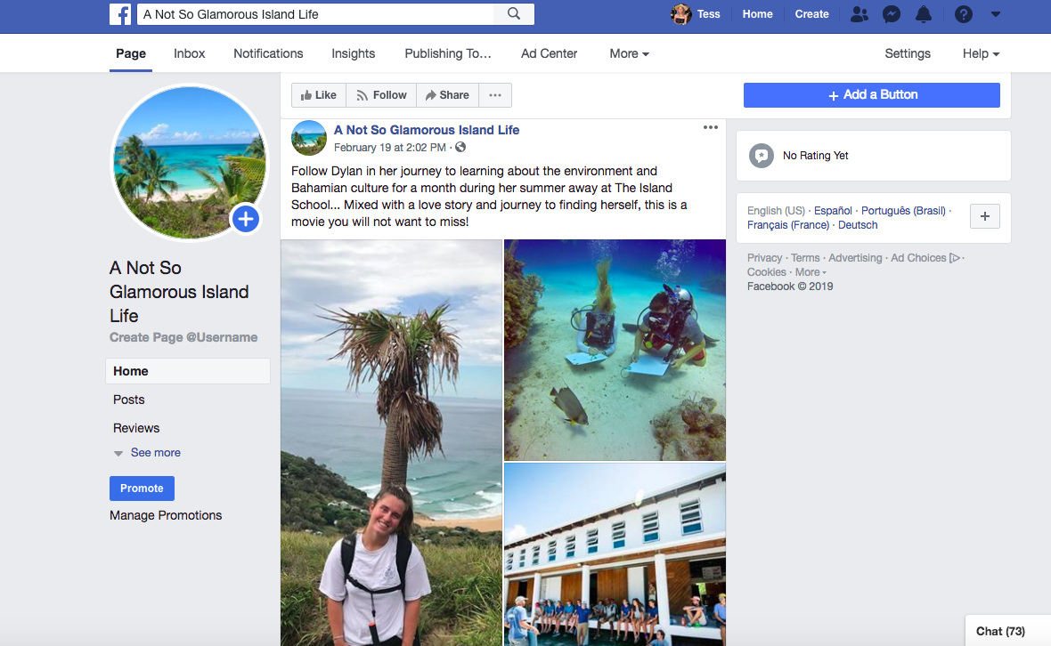

Revision Plan

What were the strengths of my draft I should keep?

One strength of my draft that I think I should keep is the Facebook page that I created. I think I did a really good job in posting things that will keep the audience interested and willing to keep visiting the page. All three peers who revised my draft also said that they enjoyed the Facebook page as well!

What design choices were problematic, and how can I revise these?

When I first submitted my draft, I knew that I wanted to work more on the movie flyer. I knew the photo I used wasn’t the best and I couldn’t decide on a font or color theme. Since I have submitted my draft, I have been working really hard on making the flyer work together with the rest of the documents by playing with different colors and different background photos.

What rhetorical choice seemed out of place in my draft, and how can I better attend to my audience, purpose, context, and genre?

One way that I want to better attend to my audience, purpose, context and genre is to really focus more on grabbing the attention of students and making them interested in coming to see a movie. Although this movie focuses around conservation and culture, it is not a documentary. It is aimed to be a comedy/love story/learning experience all in one. With that being said, I think in the e-blast as well as the feature article I can talk more to the students about why they should want to go to the movie rather than just stating facts about the movie.

What multimodal elements can I add or revise to strengthen the rhetorical effect and credibility of my project?

One element of the bundle that I would really like to strengthen in the movie flyer that I have already mentioned above. Making the flyer more appealing to the eye and emphasizing the title of the movie as well as using a powerful image will strengthen the rhetorical effect and credibility of my project. The movie flyer is something I really want to focus on and revise.

What are the most important changes I need to consider as I revise?

As mentioned before, one of the most important changed I need to consider as I revise is the movie flyer. It was messy and kind of all over the place when I first submitted the draft. Other important changed that I need to consider is creating a photo for the title page as well as creating a table of contents so that the audience of this bundle knows what the documents are about and where they can find each document.

Given the time and technology constraints of this project, what can I reasonably revise before the next due date? What else would need revision that I don’t have time to complete but should complete, given enough time and resources?

Given the time and the resources, I didn’t think I was able to create a feature article to the best of my ability. There were certain aspects of the movie that I wanted to filter in through the article but for the most part, I kept the article short and to the point. However, I will be adding a little to the article but again, not as much as I want to. Given the time and technology constraints of this project I also felt like I had to pick and choose documents that I knew I could perfect and keep the others as they were. For example, I spent a lot of time on my Facebook page and was very proud of it. There are a lot of multimodal elements so I thought revision on the Facebook page wasn’t very much needed. The movie flyer is the one document I knew I really had to revise and perfect so I wanted to make sure I had optimal time for this.

Postwrite Questions

- In what three ways did your peers help you produce a better bundle—be specific. You should outline meaningful revisions that you have made as a result of their comments. Please avoid discussing minor tweaks in grammar and punctuation here.

I was very lucky in this process where I had three peers help me to produce a better bundle. The first response I got was from Sandy and he gave very insightful recommendations for me. The one that really stuck out the most was the recommendation he made to in my e-blast and feature article to give students “more of an incentive” to go see the movie and say a little more to get college students to attend. Sandy made a good point and said that students who care about the environment will want to go but writing a little more about global warming and how it can individually affect students will attract more students to want to go to the movie. To make this change that Sandy recommended, I have added to the feature article the dangers of global climate change, the affect it has on humans all over the planet and how the movie relates to this. I have also added to the feature article the type of genre the movie is and to make it seem more light hearted rather than so serious.

The second peer revision I read was Tom’s. He not only made great suggestions but he also pointed out a few places where I didn’t realize I could make a certain change in order to make the bundle better. For example, Tom spoke about the e-blast in his recommendations. Tom said that in the beginning of the letter, it sounds like I am sending a person on a vacation rather than sending them to a movie showing. When I re-read the e-blast I completely understood where Tom was coming from. For the revision and final draft, I have changed the questions at the beginning of the e-blast and I hope this will better suit the objective of the letter.

The third peer revision I read was Meghan’s. Meghan’s revision was very easy to understand and she said everything short and to the point which I really appreciated. One revision recommendation that she made that really stood out to me in particular was about the movie flyer. I knew after I submitted the draft that I wanted to edit and revise the movie flyer. This was my number one priority to fix after the first submission. Meghan suggested that the flyer was a little plain and that it doesn’t grab the audience’s attention. I couldn’t agree more with this statement after going back and looking at the draft of the movie flyer. Meghan also suggested that I could change some of the words on the flyer to make them stand out more, for example, the word “starring” to really grab he viewer’s attention.

Overall, I really thought the peer revision process was extremely helpful in revising my bundle. I think that all three suggestions my peers made were very accurate and helped me to understand and realize changes that I could make throughout the documents.

- What did you learn about writing for different audiences/situations?

I think that the most important thing that I learned when writing for different audiences/situations is that everyone is not always going to agree with you. There were some things that my peers said about my documents that I didn’t agree with but that is okay. For example, Tom had mentioned that the Facebook page included pictures from someone’s personal Facebook rather than using photos that were dedicated to the movie. Creating the Facebook page was difficult because I did want to use a lot of visuals that represented different things. In my eyes however, they were photos that portrayed what the movie was about. Although I didn’t agree with this recommendation, I could see where he was coming from. When this happened, it made me realize that I could be more descriptive in the table of contents about the document, to better explain the document and its purpose.

Another thing I learned when writing for different audiences/situations is that certain topics may be sensitive to some people. Climate change is a topic that has caused a huge controversy in our world today. While creating this bundle, I wanted to make sure that I was being thoughtful and practical. I also understand that culture is a sensitive topic to some people as well. When writing about the Bahamian culture, I wanted to make sure I did a lot of research so that I wasn’t portraying the culture in the wrong way.

- What did you learn about yourself as a writer/researcher as a result of completing this bundle? You may wish to discuss what you discovered about your process and what works best for you, about your strengths or areas in which you could improve, or perhaps what your discovered about your personal writing style, and so on.

I learned a lot about myself throughout this project. One thing I learned is that I have a lot of good idea but don’t know how to share them with people in a simple way. For example, I had so many ideas and different components that I wanted to add to the documents and to the storyline of the movie, however, when I put everything down on paper it was a big jumble of nonsense. From this, I learned that in the future, writing things down and taking a step back to look at the big picture really helps me to evaluate my thinking and ideas. As a writer, I learned that I do a good job at directing a topic towards an audience or individual person. When writing the feature article, I really felt like I was able to add my own voice into the writing and I think this added a personal dynamic to the entire document. Even though it was made up, I thought I did a good job with picking quotes, information and portraying the movie in a way that was light hearted and easy for people to read.

A place where I can improve is my time management. As a journalism major, it is expected to be on top of deadlines and I am. However, throughout this project I realized that I could have spent more time on certain things rather than others. For example, if I spent the same amount of time on the movie flyer as I did on the Facebook page, the movie flyer could have been a lot better. Now I am spending that time revising the movie flyer but if I had made the time for it earlier on in the process, I wouldn’t be in this position now.

One of my strengths that I recognized throughout this project was my organization. Putting each document on a different word document allowed me to individualize each document and really perfect them. Then when the documents were complete I put them all together in a very neat and organized fashion. I always knew I was organized but when it came down to creating five different documents, it really put this strength of mine to the test and I think that it really shined through.

- What did you learn from this project that might be able to use in some other aspect of your academic career/future life?

One thing that I learned from this project that I might be able to use in some other aspect of my academic career/future life is the importance of peer review. As a teenager in high school, my teachers always had us do peer reviews in class but no one ever took it seriously. For this project however, the peer reviews were an absolute crucial part in completing my bundle and helping to make it the best that it could possibly be. From this experience, I will take the importance of peer revision with me through all of my classes and for my future life. An outside opinion can help you gain perspective and can also make you realize things that you may not have realized before. Overall, this project was incredible and I really enjoyed it. Although it took a lot of time and hard work, I am so proud of the final draft and I have myself, my peers and the professor to thank for that!

